Zander Giuffrida
Partner: Kevin Chau
Station: 8
February 17, 2015
LAB 3 – DIODES
INTRODUCTION

Up to this lab the focus has been on analyzing and constructing linear circuits. In this lab we attempt to delve into the much richer topic of nonlinear circuitry, which plays an important role in modern electronics. Since nonlinear elements are by deﬁnition nonlinear they are much more diﬃcult to analyze than their linear counterparts. Thus, in this lab we attempt to learn several techniques in analyzing and predicting the eﬀects of such elements. In particular, this lab focuses on the diode which is important for rectifying the output signal of a circuit. Utilizing various techniques including graphical load line analysis and perturbation analysis, we can apply linear circuit theory and thus determine the outputted signals. Although these techniques are applied to only diodes in this lab, they can be used when dealing with arbitrary nonlinear circuitry, and thus will be important in future labs.

PRELAB

1. A diode is a two terminal electrical component with asymmetric conductance; it has low (ideally zero) resistance to current in one direction (past forward threshold of about +0.6 V) and high (ideally infinite) resistance to current in the other direction (up to back threshold, which is much larger than forward threshold).

2. Suppose. Nowbut for the range of values listed. In this case, the exponential term will dominate and we can ignore the -1 term.

3. The half wave rectifier part of the circuit cuts off the negative humps in the sine wave and the low pass part cuts off higher frequencies. The load causes the capacitor to discharge between cycles causing a ripple effect. Assuming that the load current stays constant, we have that the amplitude of the ripple voltage is approximatelysince we take.

4. The load line is a function (graph) of V vs I for a linear component (like a resistor) in circuits with non linear circuits. In graphical analysis, you use the load line and the characteristic curve of the nonlinear component to find a point of equilibrium (point of intersection of the graphs). Iterative analysis is a method of guessing a current and then refining that guess by plugging in the value to the VI equations for the nonlinear and linear components. After successive refinements you get closer to the point of equilibrium. For graphical analysis you will need graphing software, but it will be more accurate / reliable. For iterative analysis you can do it by hand, but it will be less accurate / reliable.

QUESTIONS

1. We obtained a 1N448 diode and used the DMM to measure the resistance in both directions. When we connect the red lead to anode and the black lead to cathode on the diode we get a resistance ofwhich is around the expected forward resistance of. Since the meter attempts to provide about 1mA of current on thescale, we have a voltage drop across the diode of about 0.622V. When we connect the red lead to cathode and the black lead to anode on the diode the DMM outputs OVLD (overload). This means that the resistance is above the range of resistance values that the DMM can measure. This confirms that the diode conducts asymmetrically.

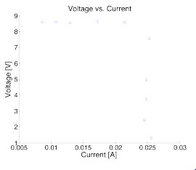
2. We obtained a plastic-stick-mounted 1N448 diode and repeated the measurement of the forward voltage drop using the DMM. This time we got a forward resistance ofwith a forward voltage drop of 0.6204V. Next we squeezed the diode between our fingers in order to heat it. When heated this way the resistance of the diode changed towith a forward voltage drop of 0.609V. Next we dipped the diode in liquid nitrogen and obtained a resistance ofwith a forward voltage drop of 1.06V. It is clear from these measurements that the voltage drop across the diode is dependent on temperature.

3. The output voltage of the offset adder, with nothing attached to input, ranges from -8.67V to 8.67V. By loading the output with several resistors values, and using Ohm's law to plot a V-I curve, we show that the circuit is a relatively stiff (low output impedance) voltage source so long as the output current is kept below approximately 24mA.

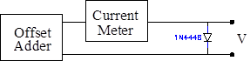
4. Using the circuit shown on the right we varied the voltage across the diode with the offset adder in order to plot the current of the diode vs. the voltage drop across it. The resulting characteristic curve is shown below on a linear plot and a log-linear plot.
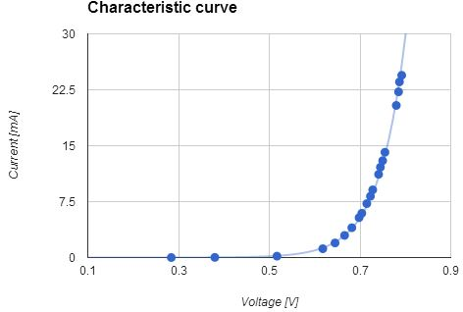
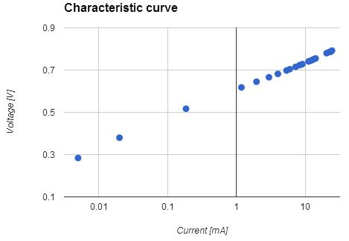

5.

Using the curve tracer we obtained the characteristic curves shown below for the 1N448 diode, 1N448 diode on a stick at room temperature, and the 1N448 diode on a stick immersed in liquid nitrogen. We add the points that we obtained from part 3.4 to the graph of the characteristic curve of the 1N448 diode. The saturation currents and voltage coefficients for each of the diodes is shown below. When the diode on a stick was at room temperature we computed n to be 2.02. When the diode was immersed in liquid nitrogen we computed n to be 2.77. We label the voltage coefficient by c (see relation below).

 | Saturation current | Voltage coefficient | n
Diode stick room temp. |  | 19.8 | 2.02
Diode liquid nitrogen |  | 19.8 | 2.77

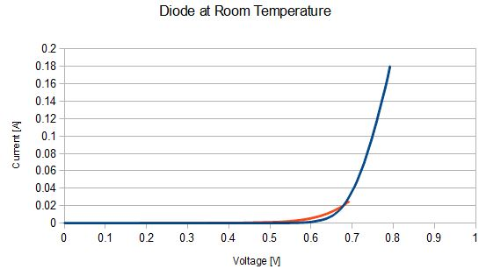
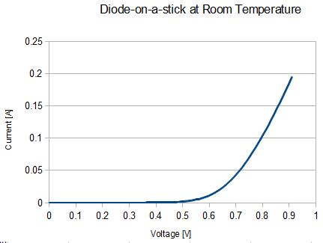

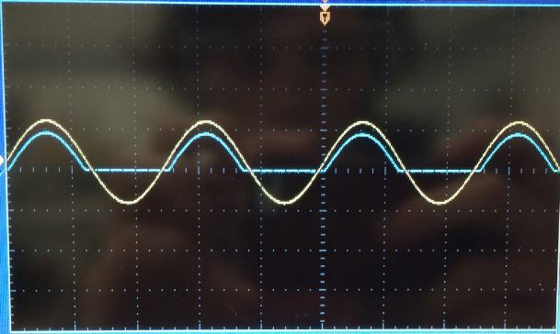

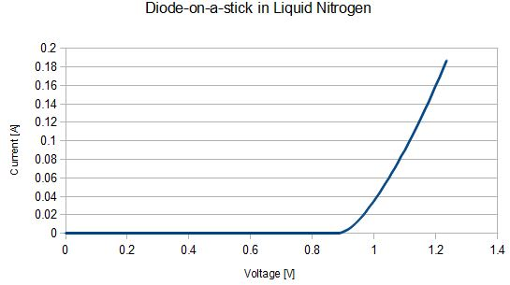

6. We measured the reverse diode current at -12V using the circuit below. The actual value of the resistors wasand the measured voltage drop across the resistor was 15mV. From Ohm's law we get that the current through the resistor was I = V/R = 14.9 nA. Since the diode is in series with the resistor, the current flowing through the diode is also 14.9 nA.
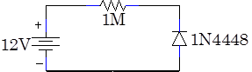

7. We built the half-wave rectifier circuit below. The actual value of the 47k resistor was. We set the DC offset adder to zero offset (actual offset 1.08mV which was as close as we could get) to prevent the rectifier circuit from charging up the output capacitor of the signal generator. Using both channels of the scope, we looked at the voltage across the AC source (yellow) and the circuit output (blue). A picture of these traces is shown below. Since the diode does not allow current to flow when it is negatively biased we get no current when the AC source is negative, which causes the lower half of the signal to be cut off. We also get some attenuation of the input signal due to the voltage drop of the diode when it is forward biased.
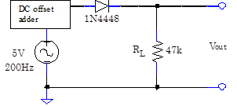

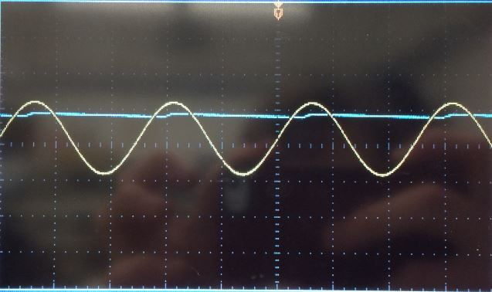
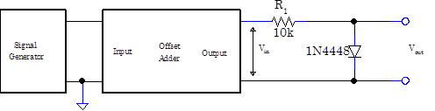
8. Next we modified our half-rectifier circuit by adding acapacitor (actual value 938.68 nF) as shown in the circuit diagram. The capacitor allows for charge to be stored while the input voltage is positive (since current flows through the diode). When the output voltage is negative (and so the diode prevents flow of current back out of the capacitor) charge flows out of the capacitor smoothing out the output signal. The capacitor value is chosen so that the time constant for discharging is much longer than the time between recharging. Even with the capacitor we still get a small ripple voltage since the load causes the capacitor to discharge somewhat between cycles. From our analysis of the circuit in problem 15 we have that the peak to peak amplitude of the ripple is related to the input voltage, input frequency, filter capacitance, and load resistance as such. When we doubled the capacitance (by adding an additionalcapacitor in parallel, actual value 944.32 nF)the ripple decreased in size. When we doubled the input frequency, the ripple decreased in size. When we doubled the resistance, the ripple decreased in size. All of these results agree with the relation we derived in problem 15.
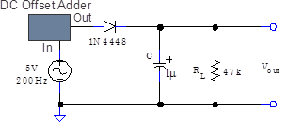

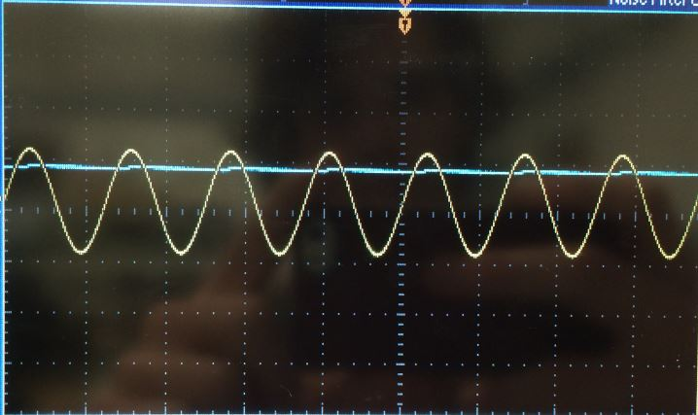
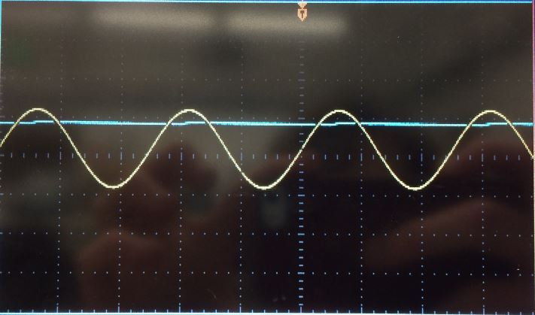
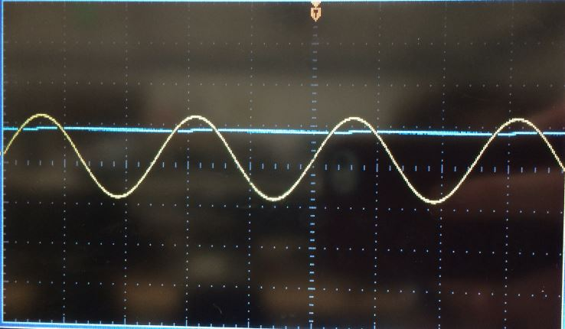

9. Using the same diode as before, we built the circuit shown below. We studied the DC response of the circuit by disconnecting the signal generator and varying the input voltage by adjusting the knob on the offset adder. Next we replaced theresistor (actual value) with aresistor (actual value) and repeated our measurements. Our values for input voltage vs. output voltage for the two resistors are shown in the tables below. Using the graph of the diode characteristic we obtained in 3.5, we perform a graphical load line analysis for each of the resistors by plotting the each of the characteristic curves for the resistors on the same graph as the characteristic curve of the diode. Since the voltage values at the intersection of the curves determines the output voltage, it is clear that the measured values come close to what we expect from the load line analysis.

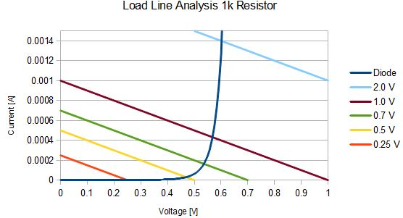
Table 1:
Vin | Vout
0.25 V | 0.2492 V
0.5 V | 0.4618 V
0.7 V | 0.5324 V
1.0 V | 0.5761 V
2.0 V | 0.6307 V

Table 2:
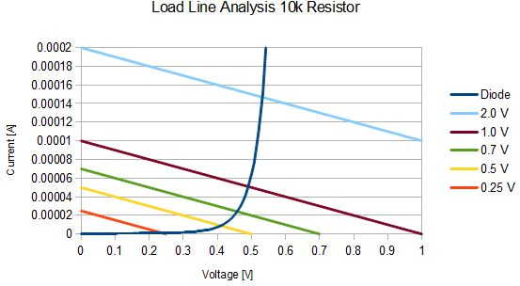  Vin | Vout
0.25 V | 0.242 V
0.5 V | 0.395 V
0.7 V | 0.436 V
1.0 V | 0.47 V
2.0 V | 0.518 V

10. When a signal is connected to the offset adder's input, the adder's output is the sum of the input signal and the internal offset by the offset adjust knob. We reconnected the signal generator to the offset adder, and temporarily disconnected the resistor and the diode. We found that turning the knob changes the output signal by a constant voltage.

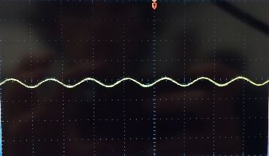
11. We reconnected the 10k resistor (actual value) and the diode to the offset adder. And we adjusted the signal generator and offset adder to produce a 0.1 Vpp sine wave at 200 Hz with a +1V DC offset. The output trace was a sine wave (not rectiﬁed). The lower half of the signal was cutoﬀ in 3.7 because the input voltage was at times negative and thus no current would ﬂow. However, with the addition of the oﬀset adder the input voltage (the sum of the AC voltage and the oﬀset adder voltage) is always positive. Thus current will ﬂow through the diode and the output signal will not be rectiﬁed.

12. Using the values for the DC offset from 3.9, we record the amplitude of the AC component of the output signal. A plot of this data is shown below. When we increase DC offset from 0V to 2V the amplitude of the AC component of the output signal decreases.
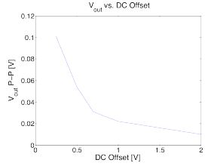

13. We construct the circuit below using an LED for the diode. When the LED is hooked up this way the voltage drop across the resistor is 0V, which demonstrates that there is no current flowing through the LED. Next we swapped the power supply polarity and the LED lit up. A plot of the voltage drop across the resistor and LED for different resistor values is listed below. As the resistor value increased, the voltage drop across the resistor increased and the forward voltage drop across the LED decreased. As voltage drop across the LED decreased, the power it dissipated decreased, and so the intensity of the light emitted decreased (brightness decreased).
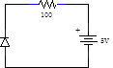
Resistor | Voltage across LED
100 Ω | 2.3502 V
300 Ω | 2.078 V
3.3 kΩ | 1.8763 V
33 kΩ | 1.7739 V
330 kΩ | 1.6846 V

14. The characteristic curve for the LED found with the curve tracer is shown below.
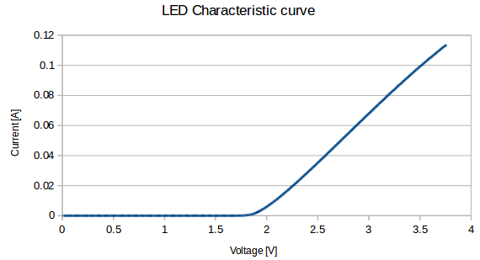

15. We will derive the approximate expression for the peak to peak amplitude of the ripple in the rectifier built in 3.8 as a function of the input voltage, input frequency, load resistor, and filter capacitor. When the AC voltage is positive, the capacitor will charge until it reaches a potential. Then as the AC voltage goes negative, the capacitor will discharge and the voltage will drop exponentially according towhere. Letbe the amplitude of the ripple, then at the end of one period. Thus. Assuming that the time it takes the capacitor to discharge is much longer than the period (which is reasonable because we chose a capacitance so that the time constant for discharging is much longer than the time between recharging), then we can approximateto first order inas such. Thuswhereis the frequency of the AC voltage source. Sincewe have. As stated in 3.8, this relation agrees with the measurements we performed on the circuit. That is, increasing the input frequency, load resistance, or filter capacitor should cause the ripple amplitude to decrease and increasing the input voltage should cause the ripple amplitude to increase.

16. We perform graphical perturbation analysis for the DC offsets of 0.2 V, 0.5 V, and 1 V from exercise 3.12. Since the AC voltage had an amplitude of 0.05 V, by linearizing the diode characteristic around the operating point, we can ﬁnd the intersection of this tangent line with the load lines at the DC oﬀset plus and minus 0.05 V. The diﬀerence between the voltages at these intersections should produce an estimate for the peak-to-peak voltage of the AC signal. The plots describing showing the load lines and diode characteristics are shown in the plots below. The values we obtained for the AC voltages were 0.95V for the 0.2 V offset, 0.025V for the 0.5 V offset, 0.015 for the 1 V offset.

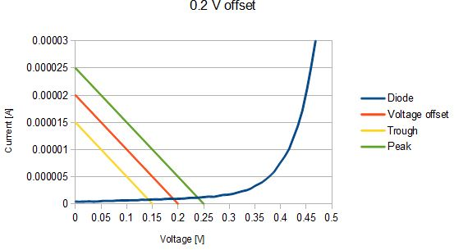

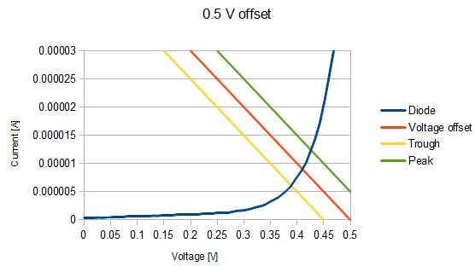

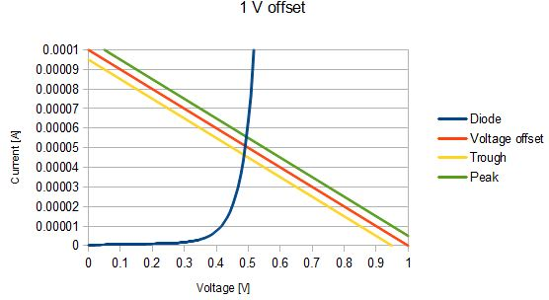

17. By producing a tangent line at the operating points of the values, we computed the resistance of the diode at those points to be 1.76MΩ for 0.25 V, 6.06kΩ for 0.5 V, and 733Ω for 1 V. Using the voltage divider equation we getwhere R = 10kΩ andis the voltage of the AC input signal (which is 0.1V ). Plotting this on the same graph as in question 3.12, we see that that these calculated values are on the same order of magnitude as the measured values. A large AC signal corresponds to large perturbations. From the graph of the diode characteristic below, we that the actual resistances of the diode at the peaks and troughs of the signal are no longer well approximated by the the resistance value at the DC oﬀset. Using the tangent line, we can compute the output signal to have a peak-to-peak voltage given by the diﬀerence in the dark blue lines, while the actual peak-to-peak voltage is given the red lines. Since the red lines are closer together than the blue lines, the large signal impedance would produce a value much greater than what we might measure.

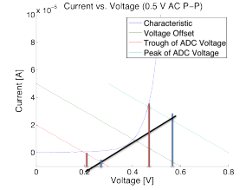  DC Offset | Zdiode | Vin | Vout
0.25 V | 1.76 MΩ | 0.1 V | 0.099 V
0.5 V | 6.06 kΩ | 0.1 V | 0.038 V
1.0 V | 733 Ω | 0.1 V | 0.0068 V
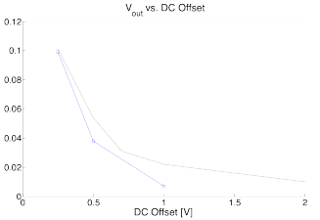

18. The characteristic curve for the 1N5234B Zener diode is shown below.
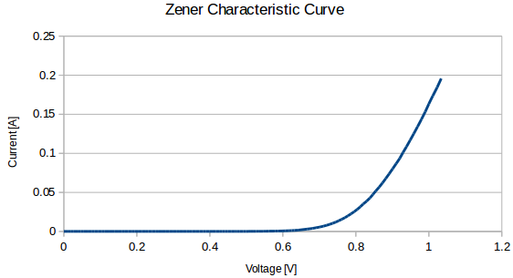
We know that the current through the diode can be modeled bywhereis the voltage across the diode and c is the voltage coefficient. In addition, by Ohm’s Law the current across the resistor iswhereis the source voltage. Since the diode and resistor are in series, and therefore. Since we want the voltage across the diode to be 6.2V andand the voltage coeﬃcient were measured to be 1.36 × 10−7 A and 25.46 respectively, then we can estimate the resistor value to be approximately 152.5 Ω. Experimentally, we measured the resistor value to be approximately 220Ω. Note that the reasonable discrepancy between these values can be attributed to the fact that since the characteristic curve is exponential, small changes in the voltage coeﬃcient will lead to very diﬀerent resistor values. We determined that 680Ω was the smallest load resistor value which would not signiﬁcantly decrease the circuit output voltage (we considered a significant decrease to be at least 1%).

19. Using Multisim, we simulated the circuit shown below. We set the input AC voltage to have an amplitude of 0.00001 V. The input voltage and output voltage, along with their corresponding Fourier decompositions, are shown in the plots below. Since the signal is not greatly distorted by the circuit we would expect the output voltage to have a single peak, which corresponds to a sine wave. When the wave AC voltage is raised to 1 V, there is much greater distortion of the wave. It is clear from that this distortion from a perfect sine wave will contribute greatly to frequencies other than the ﬁrst harmonic. Thus, the second harmonic will correspond to a higher voltage, and we will see signiﬁcant frequency doubling for voltages of 0.3 V or higher.
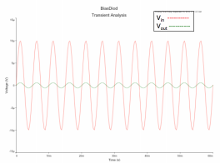
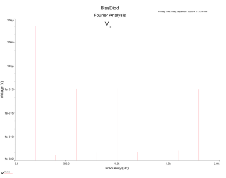
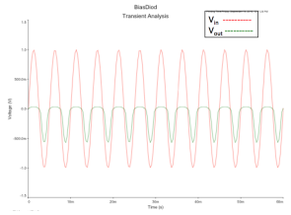
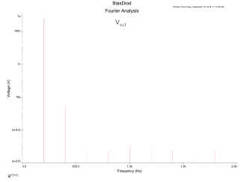
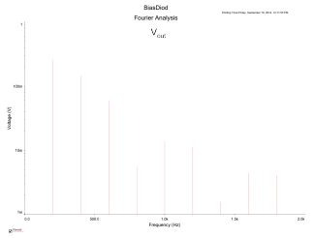

CONCLUSION

In this lab, we studied the eﬀect of diodes on the circuit. We applied graphical load analysis and perturbation analysis to determine resulting voltages and currents. From our results, it is clear that these are fairly powerful and precise techniques for determining the resulting voltages and currents of the circuits. Utilizing the diode, we were able to rectify signals, a result which is much more diﬃcult, if not impossible to achieve with linear circuit elements. This understanding of diodes will be very important when we study transistors in future labs.

